Assignment 4 LCD Interface

Released Date: Oct 31th

Version 1.0

**Task 1** 4 LEDs are connected to Arduino Uno, try to use LCD1602 to display the current state of LED been lighted.

任务1 使用3个LED连接至Arduino Uno，使用LCD1602 显示当前小灯点亮的状态，（1s位移）。

**You could use Tinker CAD or Proteus for the verifying.可使用在线工具Tinker CAD或Proteus进行仿真。**

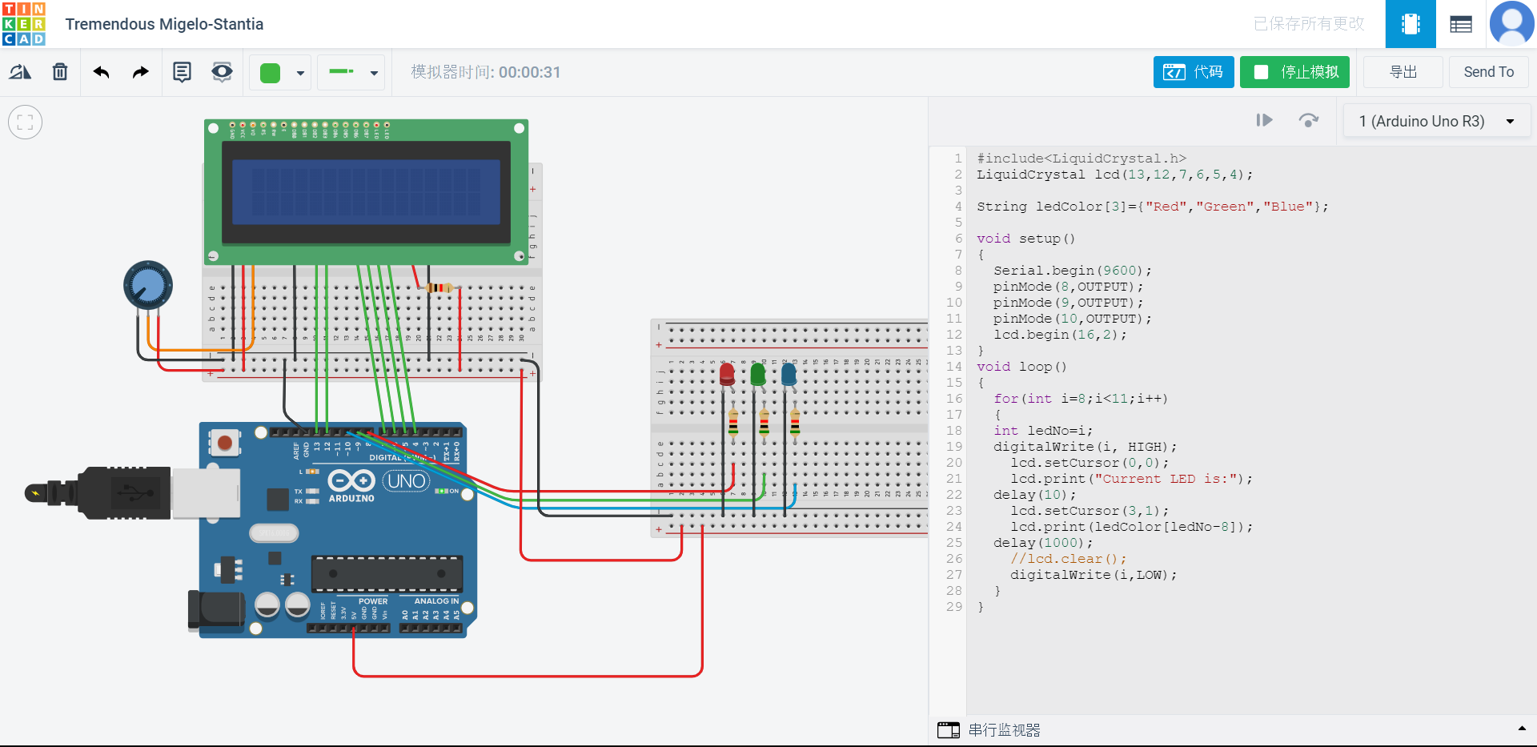

**#include<LiquidCrystal.h>**

**LiquidCrystal lcd(13,12,7,6,5,4);**

**String ledColor[3]={"Red","Green","Blue"};**

**void setup()**

**{**

**Serial.begin(9600);**

**pinMode(8,OUTPUT);**

**pinMode(9,OUTPUT);**

**pinMode(10,OUTPUT);**

**lcd.begin(16,2);**

**}**

**void loop()**

**{**

**for(int i=8;i<11;i++)**

**{**

**int ledNo=i;**

**digitalWrite(i, HIGH);**

**lcd.setCursor(0,0);**

**lcd.print("Current LED is:");**

**delay(10);**

**lcd.setCursor(3,1);**

**lcd.print(ledColor[ledNo-8]);**

**delay(1000);**

**//lcd.clear();**

**digitalWrite(i,LOW);**

**}**

**}**